Why be enemies when being friends is better? Persuading the insurgents to turn over their weapons is not just going to end a war, but restore a positive relationship with Afghanistan. Most insurgents are trying to make a living for their family. It will take some time, but with the right actions it can be done. Communicating the benefits of ceasing hostilities is the key task.

Using the things that are important to Afghanis will help greatly . Afghanis are traditionally inspired by money, power, and religion, so by showing that stopping conflict will bring a better economy will provide an more desirable future. Also, helping to strengthen their government will give them a sense of power. The second way to persuade them is using their religion. Afghanis feel very strongly about their faith. Respecting and supporting their religion will develop trust.

Three main methods will convince insurgents to lay down their weapons. First, demonstrate ending conflict would cease large scale loss of life by talking with – not to them – about how their religion respects life. Aligning with a superpower instantly props up native military and law enforcement that will protect and serve that respected life Security would allow infrastructure and utility development for power, water, transportation, and health care. Constantly broadcasting visual and audio messages of what there is to gain from ending conflict is crucial. Third, we would show them that we will respect their culture by rebuilding and securing mosques and holy sites. These steps will show fighting is not necessary “to win” and the mutual benefits outweigh the cost of loss.

Many themes could help eliminate violence like emphasizing developing relationships around common interests. One way we can connect is through money. Everyone can relate to the need of currency to provide for others or themselves. It is just like our parents going to work but the insurgents do it in a way we, as Americans, view negatively. We can help rebuild the country, ultimately creating nonviolent jobs for their citizens. Having these relationships would be the best angle to ending conflict.

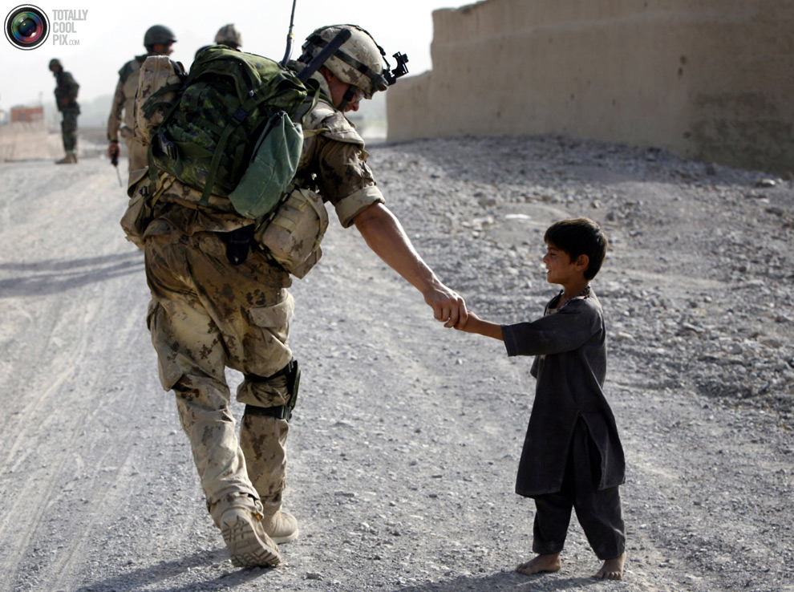

**Why have enemies when they would be such great friends?**